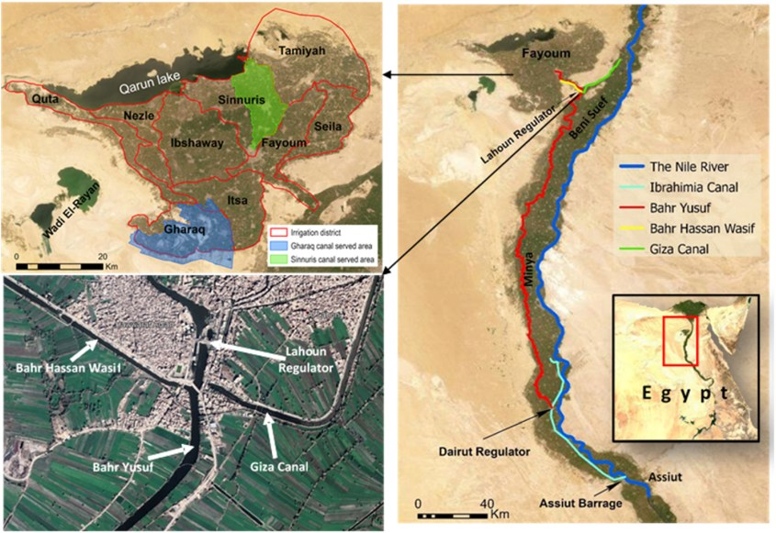
Main canals, regulators, irrigation districts of the Fayoum Governorate, and Sinnuris-canals’ served area
Sinnuris-Canal Served area location:
Longitudes: 30° 46′ 52.1″ to 30° 55′ 31.5″ E
Latitudes: 29° 19′ 31.4″ to 29° 31′ 19.3″ N

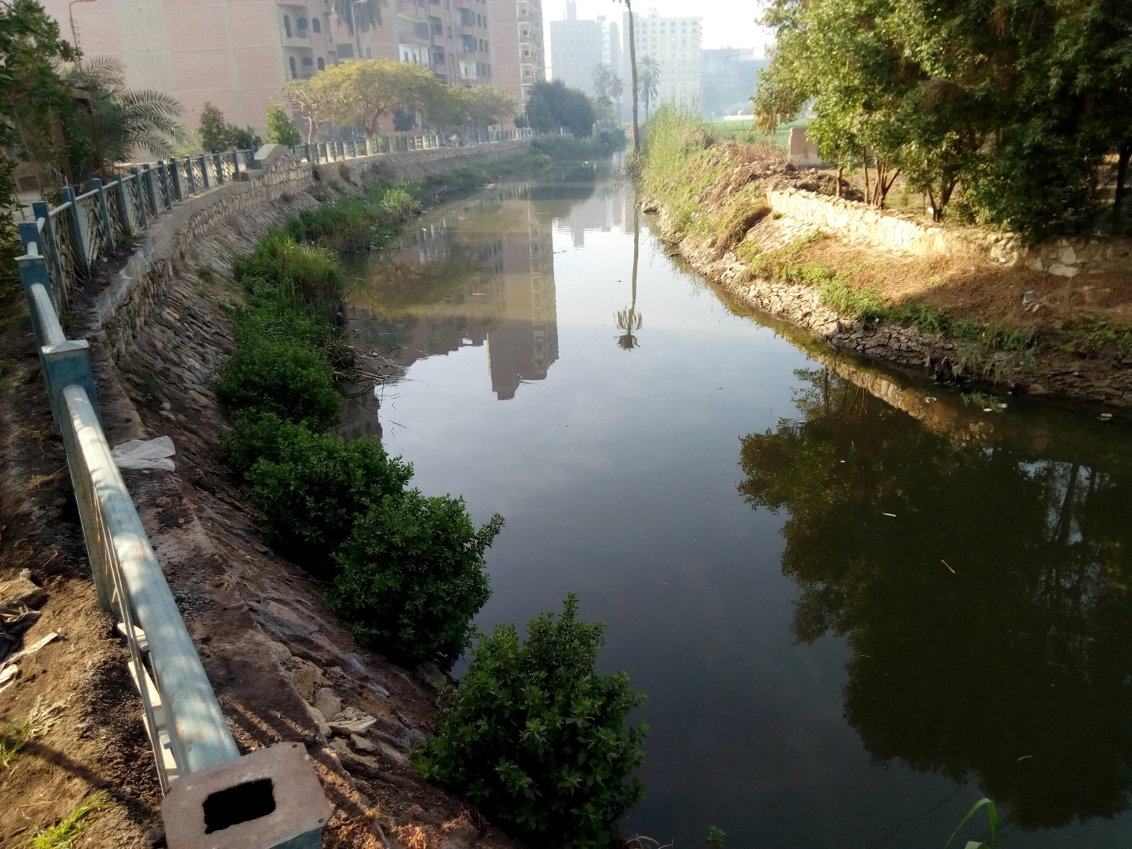
بحر سنورس العمومي Sinnuris Main Canal
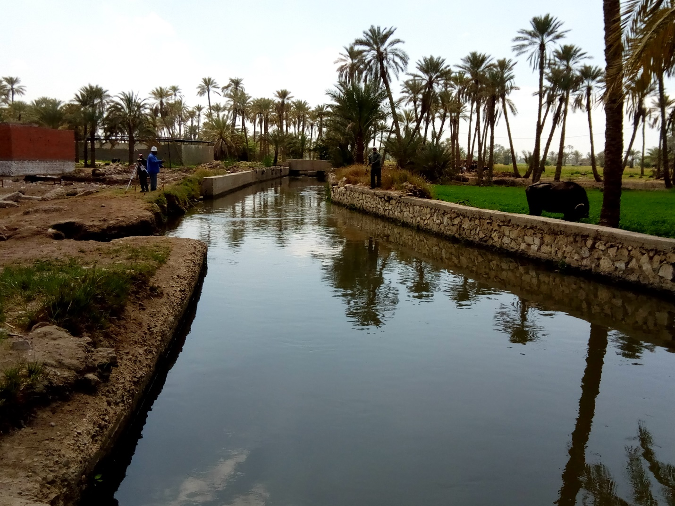
بحر سنورس العمومي Sinnuris Main Canal
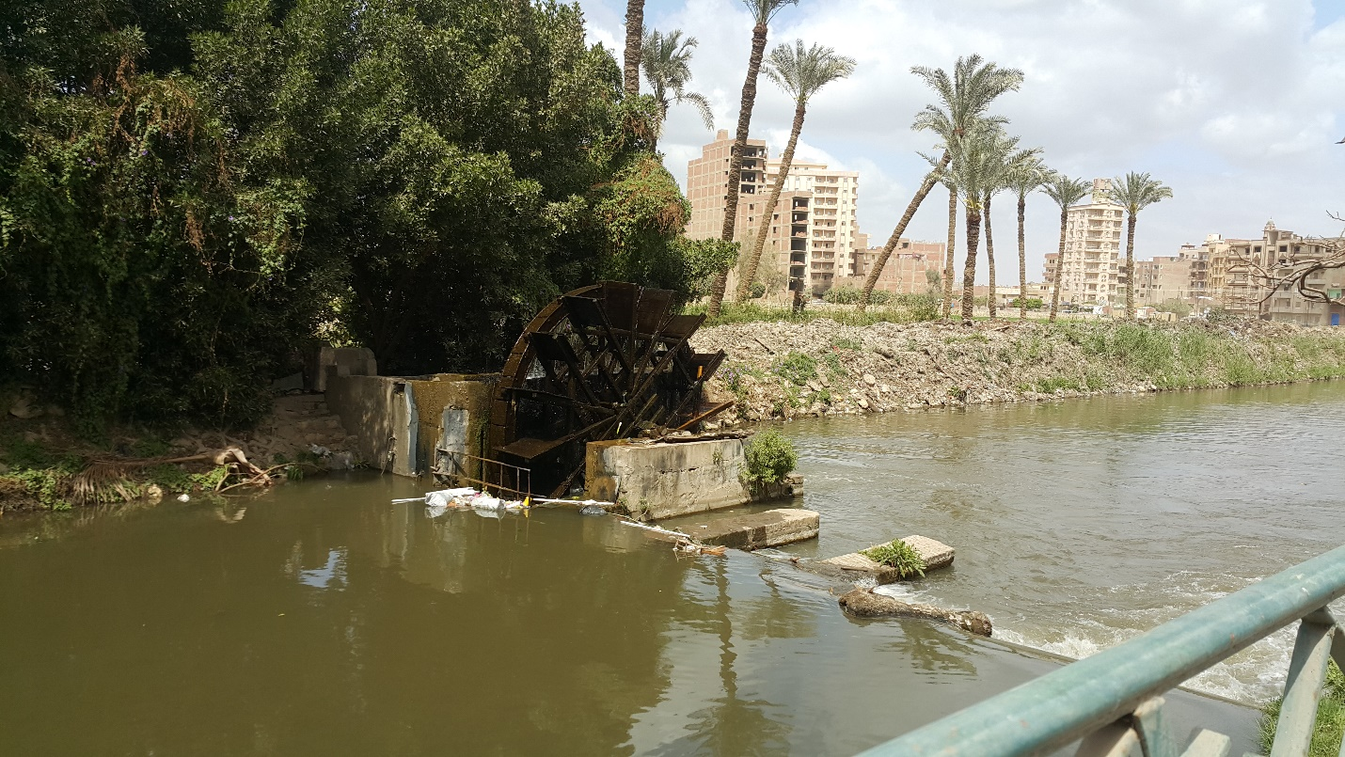
بحر سنورس العمومي Sinnuris Main Canal
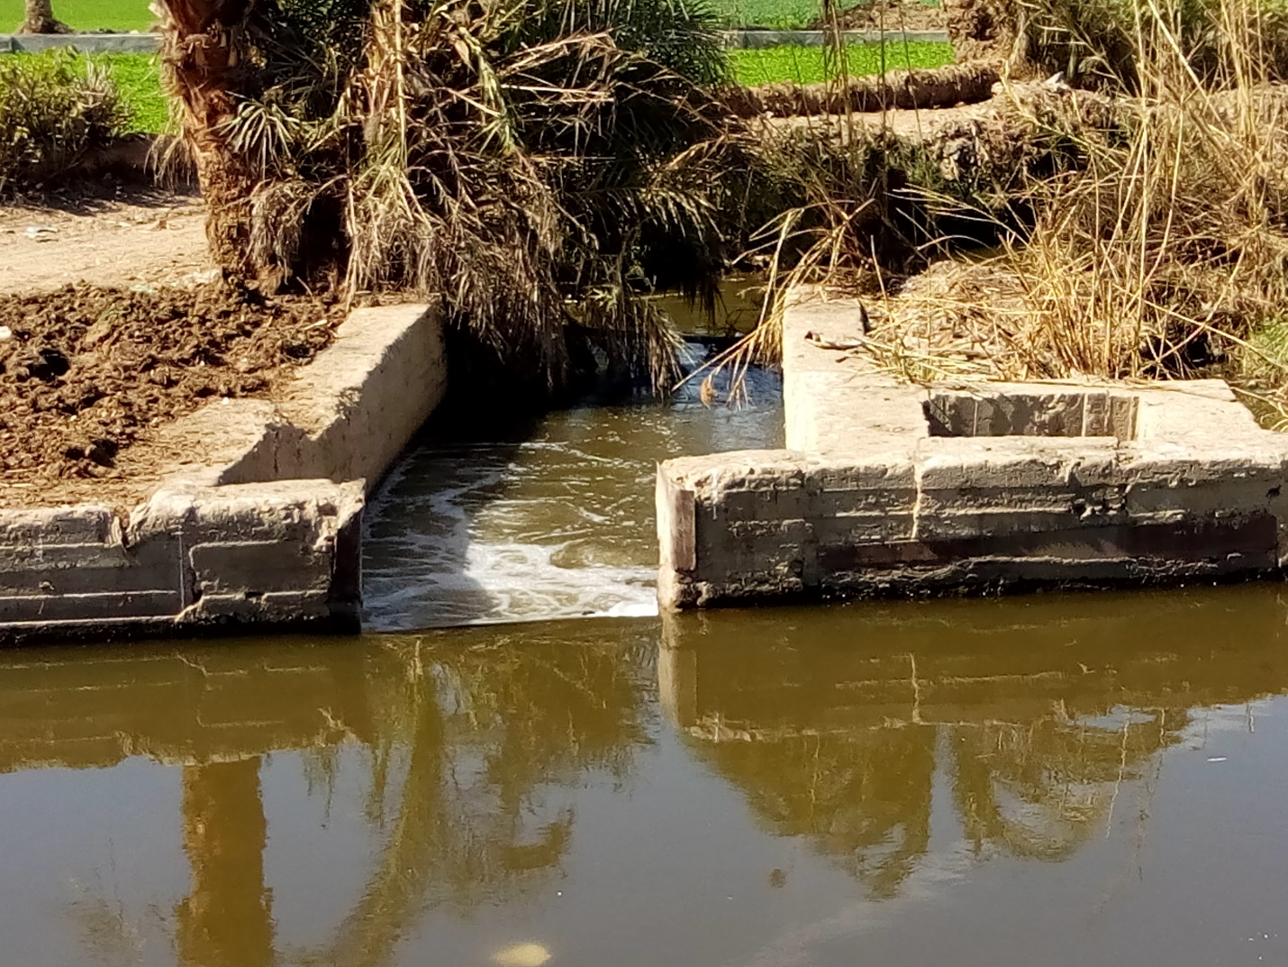
فم بحر بيهمو Distributary Head Regulator – Biyahmo Sub-canal

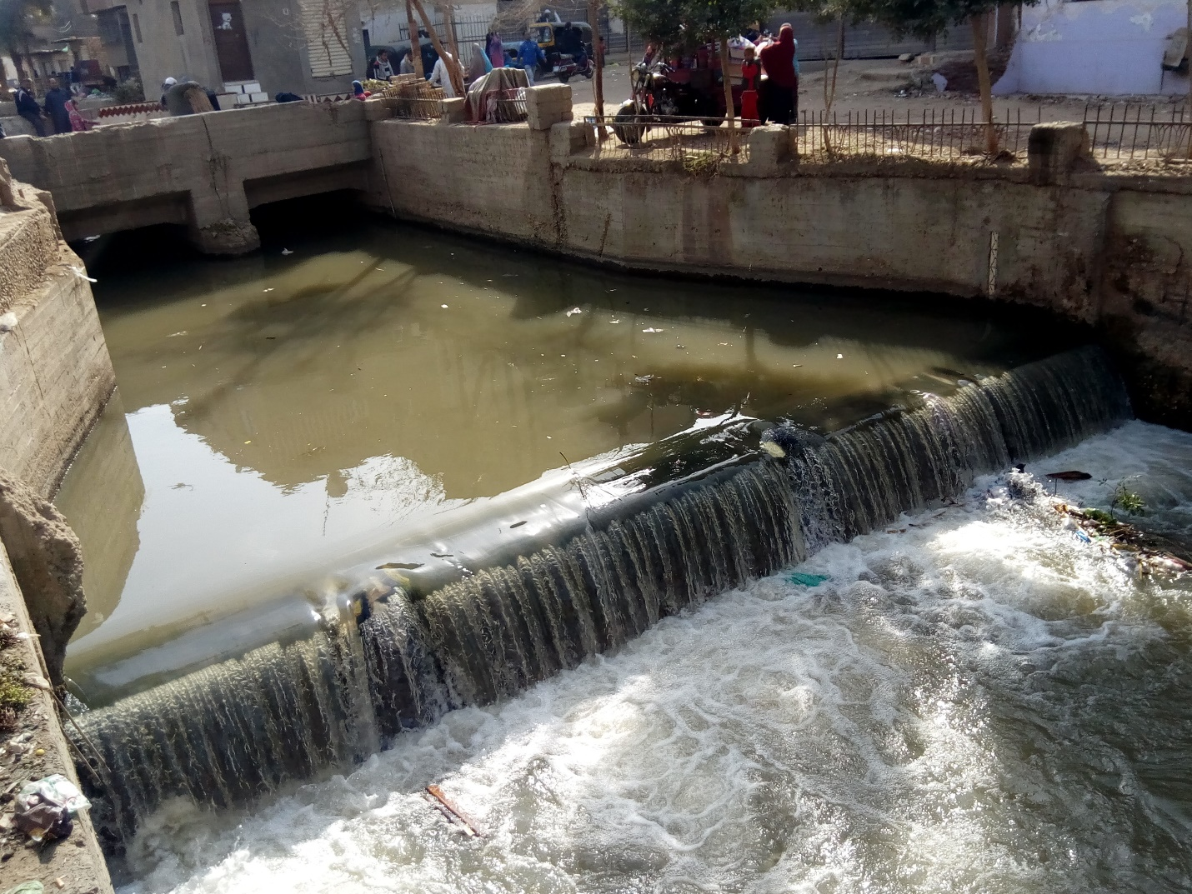
بحر ترسا Tersa canal
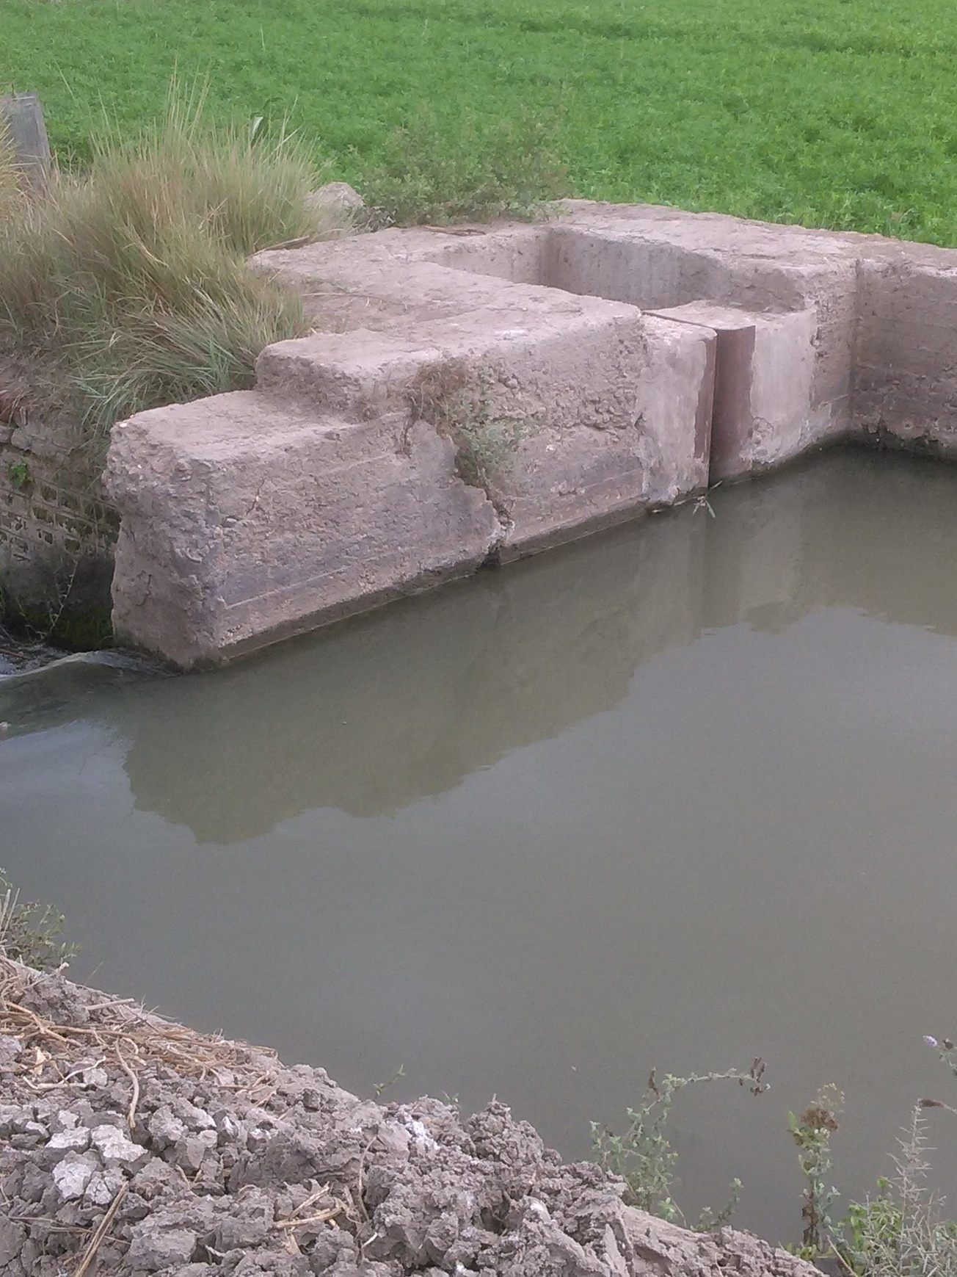
نهاية بحر مطرطارس End of Moturtaris Canal

